SQL Queries For Project_customer_segmentation
- How is the shopping distribution according to gender?
SELECT gender, COUNT(invoice_no) AS shipping_distribution FROM customer GROUP BY gender;
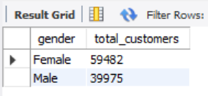
Insights:
The analysis indicates a nearly balanced participation between male and female shoppers, with a slight dominance of female customers.
This suggests that marketing efforts resonate more with women, who may exhibit higher engagement levels in retail activities.

- Which gender did we sell more products to?
SELECT gender, SUM (quantity) AS total_products FROM customer GROUP BY gender ORDER BY total_products DESC;
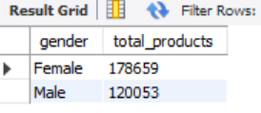
Insights:
Female customers accounted for a higher volume of product purchases compared to males.
This implies stronger purchase intent and possibly greater responsiveness to product variety and seasonal offers.

- Which gender generated more revenue?
Select gender , SUM(price*quantity) as total_revenue from customer group by gender;
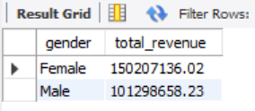
Insights:
Although both genders contribute significantly to overall sales, female shoppers generated slightly higher revenue.
This trend highlights their higher spending tendency and underlines the potential benefit of women-focused marketing strategies.

- Distribution of purchase categories relative to other columns
SELECT
category,
CASE
WHEN age BETWEEN 13 AND 19 THEN 'Teen'
WHEN age BETWEEN 20 AND 29 THEN 'Young Adult'
WHEN age BETWEEN 30 AND 44 THEN 'Adult'
WHEN age BETWEEN 45 AND 59 THEN 'Middle Age'
ELSE 'Senior'
END AS Age_Category,
COUNT(DISTINCT invoice_no) AS Unique_Invoice_C
FROM customer
GROUP BY
category,
CASE
WHEN age BETWEEN 13 AND 19 THEN 'Teen'
WHEN age BETWEEN 20 AND 29 THEN 'Young Adult'
WHEN age BETWEEN 30 AND 44 THEN 'Adult'
WHEN age BETWEEN 45 AND 59 THEN 'Middle Age'
ELSE 'Senior' END ORDER BY category, Age_Category;
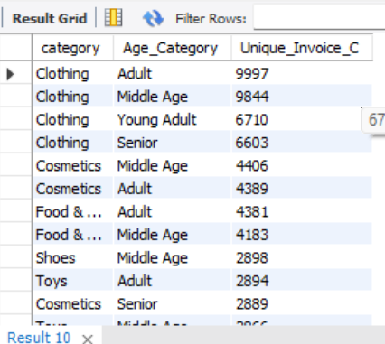
Insights:
Adults and middle-aged groups make the most purchases, mainly in clothing.
Clothing is the top category across all age groups, followed by food and cosmetics.
Younger customers show lower purchase activity compared to older groups.

- How is the shopping distribution according to age?
SELECT
CASE
WHEN age BETWEEN 13 AND 19 THEN 'Teen'
WHEN age BETWEEN 20 AND 29 THEN 'Young Adult'
WHEN age BETWEEN 30 AND 45 THEN 'Adult'
WHEN age BETWEEN 46 AND 60 THEN 'Middle Age'
ELSE 'Senior'
END AS age_category,
COUNT(invoice_no) AS total_orders
FROM customer
GROUP BY age_category
ORDER BY total_orders DESC;
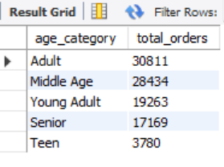
Insights:
Adults have the highest number of total orders (30,811), showing they are the most active buyers.
Middle-aged customers follow closely with 28,434 orders, indicating strong purchasing power.
Young adults and seniors contribute moderately with 19,263 and 17,169 orders respectively.
Teens have the lowest engagement (3,780 orders), suggesting limited buying activity or access.
- Which age cat did we sell more products to?
SELECT CASE
WHEN age < 20 THEN 'below 20'
WHEN age BETWEEN 21 AND 30 THEN '21-30'
WHEN age BETWEEN 31 AND 40 THEN '31-40'
WHEN age BETWEEN 41 AND 50 THEN '41-50'
WHEN age BETWEEN 51 AND 60 THEN '51-60'
ELSE '60+'
END AS age_group, SUM(quantity) AS total_products_sold
FROM customer GROUP BY age_group ORDER BY total_products_sold DESC;
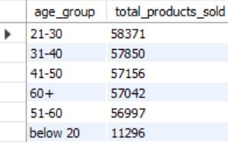

Insight:
The 21–30 age group purchased the highest number of products, highlighting their dominant shopping activity across categories.

- Which age cat generated more revenue?
SELECT
CASE
WHEN age BETWEEN 13 AND 19 THEN 'Teen'
WHEN age BETWEEN 20 AND 29 THEN 'Young Adult'
WHEN age BETWEEN 30 AND 45 THEN 'Adult'
WHEN age BETWEEN 46 AND 60 THEN 'Middle Age'
ELSE 'Senior'
END AS age_category,
SUM(quantity * price) AS total_revenue
FROM customer
GROUP BY age_category
ORDER BY total_revenue DESC;
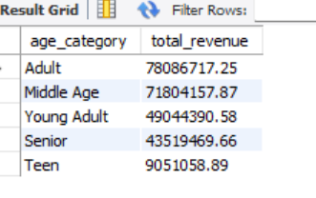
Insights:
Adults and middle-aged groups generate the highest revenue, showing strong purchasing power.
Young adults contribute moderately, while seniors and teens have minimal spending.
Overall, adults lead revenue generation, indicating they are the primary target customer group.

- Distribution of purchase categories relative to other columns?
- Category vs Gender
SELECT
CASE
WHEN age BETWEEN 13 AND 19 THEN 'Teen'
WHEN age BETWEEN 20 AND 29 THEN 'Young Adult'
WHEN age BETWEEN 30 AND 45 THEN 'Adult'
WHEN age BETWEEN 46 AND 60 THEN 'Middle Age'
ELSE 'Senior'
END AS age_category,
category,
COUNT(invoice_no) AS total_orders
FROM customer
GROUP BY
CASE
WHEN age BETWEEN 13 AND 19 THEN 'Teen'
WHEN age BETWEEN 20 AND 29 THEN 'Young Adult'
WHEN age BETWEEN 30 AND 45 THEN 'Adult'
WHEN age BETWEEN 46 AND 60 THEN 'Middle Age'
ELSE 'Senior'
END,
category
ORDER BY
age_category,
total_orders DESC;

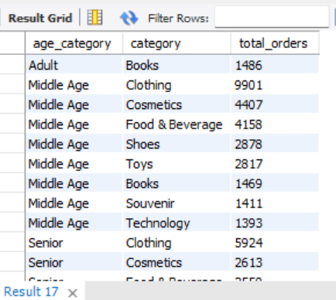

Insights:
Adults contribute the highest total revenue, followed closely by the middle-aged group, showing strong purchasing engagement.
Young adults and seniors generate moderate revenue levels, indicating balanced participation.
Teens show the lowest revenue contribution, suggesting limited purchasing activity in that age group.

- Does the payment method have a relation with other columns?
SELECT
payment_method,
gender,
CASE
WHEN age BETWEEN 13 AND 19 THEN 'Teen'
WHEN age BETWEEN 20 AND 29 THEN 'Young Adult'
WHEN age BETWEEN 30 AND 45 THEN 'Adult'
WHEN age BETWEEN 46 AND 60 THEN 'Middle Age'
ELSE 'Senior'
END AS age_category,
COUNT(invoice_no) AS total_orders
FROM customer
GROUP BY payment_method ,gender,age_category
ORDER BY payment_method, gender, total_orders DESC;
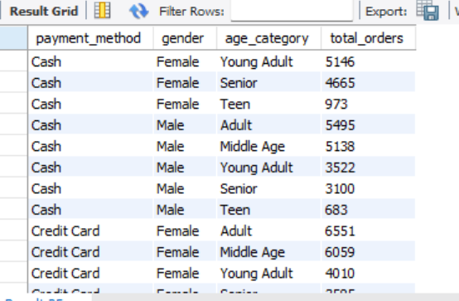
Insights:
Adults lead in total revenue, indicating they are the primary target group for sales.
Middle-aged customers follow closely, showing strong buying power.
Young adults and seniors contribute moderately, while teens have the least impact on overall revenue.
10. How is the distribution of the payment method?
SELECT
payment_method,
COUNT(invoice_no) AS total_orders,
SUM(quantity * price) AS total_revenue,
ROUND(AVG(quantity * price), 2) AS avg_order_value
FROM customer
GROUP BY payment_method
ORDER BY total_revenue DESC;

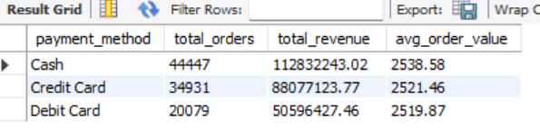

Insights:
Cash is the most preferred payment method, generating the highest revenue and number of orders.
Credit cards follow closely, contributing significantly to overall sales.
Debit cards are the least used, showing lower order volume and revenue compared to other methods.

